Assignment 2bis: Text interface for Route Registration (14 points)
Create a command-line interface to allow a user to enter a new route into the csv file with the route information. The interface should look something like:
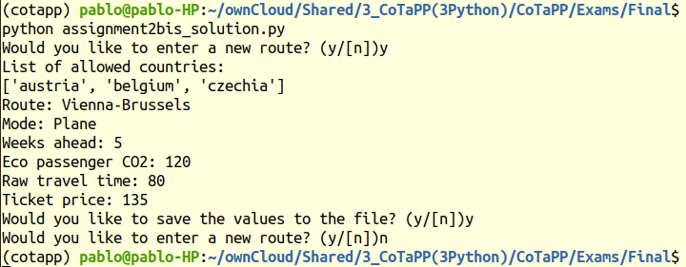
The user can enter the required data and then save it to the file, or exit the interface. The file assignment2_skeleton.py already contains the main program for starting the interface (don’t change!) and some predefined classes, functions and methods. Implement them as described in the following:
No. | Description | Points
1 | Method write_values  Appends a tuple of values to a csvfile | 2
2 | Method read_values  First prints out the allowed countries by calling the get_country_names method mentioned below. Then asks the user to enter the required values one after another. Returns a tuple with the values in the order entered by the user | 4
3 | Method runInterface  Creates an eternal while loop in which the user is first asked whether s/he wants to continue entering routes. If the user answers y, the read_values method is called. After that the user is asked whether s/he wants to save the values to the file. If the answer is y, the write_values method is called. When the user answers anything other than y to the first question, the loop exits. When the user answers anything other than y to the second question, the values entered are ignored and not saved to the file. | 4
4 | Function get_country_names  Retrieves a list of country names in Central, Western and Northern Europe with at least 100000 inhabitants. Use the REST web services provided by  https://restcountries.com. Concretely, use the REST call https://restcountries.com/v3.1/region/europe to retrieve information about the countries in Europe, extract their names, filter out those outside the sub-regions of interest or with small populations, and return a list.  Hint: Convert the response string into JSON objects. | 4

